HAXBY & WIGGINTON U3A NEWS SHEET
JANUARY 2026

Hello and welcome to the first News Sheet of 2026! We hope that you had an enjoyable Christmas and a relaxing New Year, so you are ready to join in our 2026 activities. This year is a big year for Haxby & Wigginton u3a as we’ll be 20 years old in August. We are planning a celebration to mark the event and more details will follow later in the year. This year is also the 100th Anniversary of the Wigginton Recreation Hall, and they too are planning a big celebration, details will follow later.

SUBSCRIPTIONS.

It’s that time of year again! Wow, how fast it comes round! It’s time to renew your membership and pay our annual subscription, which has been held at £10 for the 12th year running. I know that lots of members have already paid their subscriptions, and many thanks for your prompt payments. If by any chance you have yet to pay, it will be most appreciated if you will renew and pay as soon as possible.
Our bank details for online payments are:-
Account: Haxby & Wigginton u3a
Account number: 53644227
Sort Code: 20-98-98
Please state “Renewal” and membership number as the reference.
Bank transfers are preferred, but cheques, made payable to Haxby & Wigginton U3A, may be sent to our Treasurer, Peter Murray, at:- 8 Angram Close, Clifton, York, YO30 5ZN.
Please write “Renewal” and your membership number on the back of the cheque. Thank you.

BEACON RECORDS

We are still finding that some of the telephone numbers, email addresses or emergency contact details that we have on record in Beacon are incorrect because they have changed and we have not been notified of the change. If you change either your telephone number, mobile number, address, email address, or emergency contact details, please, please notify the Membership Secretary, Wendy Mitchell, either by email, membershipsecretary@hawu3a.org or phone 07410 268490, so that we can keep our records up to date and are able to contact you. Please make sure that you have given Wendy your emergency contact details which are required for all groups, activities, trips and meetings.

VOLUNTEERS WANTED

Speaker Finder
We are still looking for a volunteer to take on the role of Speaker Finder. Mike Calvert has booked all the speakers for this year, so you would have plenty of time to get to grips with the role. Mike will be happy to answer any questions and explain the role. Please contact me, Chris Jaques on 07939 502401, and I will put you in touch with Mike.

Publicity Officer
We are still looking of a volunteer to take on the role of publicity and communications officer. Please contact me, Chris Jaques on 07939 502401 if you wish to discuss this role.

Chair Rota
We are still looking for more volunteers to help put out the chairs for the monthly meetings. The more people on the chair rota the less number of times you have to do it. Please contact me, Chris Jaques on 07939 502401, if you’re willing to volunteer.

H&W u3a Monthly Meetings Speaker Programme 2026

The monthly meetings are held at Wigginton Recreation Hall
Doors open at 13.30, start 14.00
Admission: Members £2.00 (Admission includes tea or coffee)

Friday February 20th Alan Hunton Serendipity
Alan is a retired chemist who worked in the oil industry for many years. Serendipity is a phenomenon which describes a beneficial outcome achieved purely by chance. So many scientific discoveries have come about in this way. He focuses on 10 different Eureka moments in history. A well-known example is the work of Alexander Fleming who was not studying antibiotics when he realised the importance of the mould in the petri dish which led to the discovery of penicillin.

Friday March 20th Peter Slater Don’t you know who I am?
45 years of being ignored by the rich and famous. Peter is a semi-retired former BBC sports reporter keen to share his stories of the people he has met over a 50-year career. These include an interview with the most famous man in the world, a confrontation with a drunken Brian Clough and a terrifying drive in a French hire car with a future world motor racing champion.

Friday April 17th Philip Ashe HMS Hood and the nature of human folly: ‘If it looks like a duck …’
Philip is an ex-teacher of history. He shares his story of the ship's destruction that shook the world and why it would never have happened, but for the perennial folly of people seeing only what they want to see.

Friday May 15th Robert Pullen Sleep and dreams
Following his excellent talk on the brain, retired lecturer, Dr Robert Pullen, shares his knowledge of sleep and dreams. He stresses how vital sleep is to our health and how our dreams are an essential part of that sleep as the brain tidies away all the information from the day.

Friday June 19th Philip Caine A Life Less Ordinary
Acclaimed published author and public speaker, Philip talks further about his remarkable life that saw him start working life in the hotel business to travelling the world with the oil industry, spending 7 years in post-war Baghdad and a further 3 years running oil services companies in Dubai.

Friday July 17th Dulcie Lewis ‘A Flush in the Pan’
A retired college lecturer, Dulcie writes about social history and has had a best-selling book on privies published and appeared on the media talking about different subjects, especially toilets. Humorous rather than technical, do not expect a lecture on plumbing and Thomas Crapper.

August No talk Summer break

Friday September 18th Sasha Hill The Great Train Robbery
Growing up with two police officer parents and having a natural interest in history, Sasha always found crime interesting. She has given many talks on historic and crime-related topics. The Great Train Robbery of 1963 was one of the most audacious crimes in modern history – a gang of 15 stealing approximately £2.6 million from a Royal Mail train. The talk focuses on the planning, the heist and the aftermath for those involved.

Friday October 16th Martin Lloyd Passports, Assassins, Traitors and Spies Martin worked for the HM Immigration Service for 24 years and now writes books, appears on TV and radio and is a public speaker. Martin invites us to thrill to a dramatic account of how the actions of a group of assassins brought a change in passport regulations, how the unmasking of a spy caused a modification in passport design and how, for one man, the passport itself turned into a killer.

Friday November 20th AGM & Peter Mathers Poetry, Prose and Peonies
Peter brings together his love for literature and gardens by talking about literary figures and famous individuals who had a special link to their gardens (including Shandy Hall, Coxwold.)

The December meeting is replaced by the Christmas Social. Details to follow nearer the time.

NEW GROUP

A new group has been started for Cribbage. If you are interested in playing Cribbage please contact the Group Leader, Graham Elphee, at email graham.elphee@gmail.com or our Groups Co-ordinator, Trevor Bardy, at email groupscoordinator@hawu3a.org

HISTORY WALKING TOURS OF YORK

How well do you know your own City?
If you wish to learn more about the history of our city and to explore its hidden corners, consider joining the H&W u3a Historical Walking Tours of York.
These tours run in September and they are best regarded as a short course, looking at each area of York in detail during each of the 7 two hour walking tours.
The invitation is open to all U3A members, including those who have done the walks before, but spaces quickly disappear, so be quick to sign up.
If you are interested, please contact:
Neil Moran
01904 768687
07852 536319

Email:- neilmoran51@gmail.com

SUMMER SCHOOL

The Yorkshire and Humber Region u3a is organizing its annual Summer School at The Hawkhills, Easingwold, YO61 3EG, from 24th to 27th August 2026. Open to all u3a members across the region, you can attend as a resident for the 3 days at a cost of £495 per person or as a day visitor at £256 per day. There is a wide choice of subjects and activities. For more details and a booking form see their website https://yahru3a/2026-summer-school/

U3A FRIENDS NEWSLETTER

The Third Age Trust produces a monthly newsletter called u3a Friends. All u3a members can sign up to receive this newsletter to keep up to date with u3a news, events, and what other u3a’s are doing. In addition u3a Friends gets access to Friends Extra which offers discounts on travel, shopping, electronics and more. Please visit u3a website to sign up.

MOBILITY SCOOTER SAFETY PACKS

Unfortunately, accidents involving mobility scooters are on the increase. A safety campaign organisation, Surewise, has launched a nationwide initiative to promote mobility scooter safety, and has produced a “Safety Pack” containing a safety guide with information on how to stay safe, etc, and including reflective stickers to stick on your scooter to make it more visible. You can read more about the Surewise campaign at: https://www.surewise.com/safer-mobility/
We have a number of these Safety Packs to hand out to members who use a mobility scooter. If you would like one of these Safety Packs, or know of someone who uses a scooter, please contact me, Chris Jaques, 07939 502401, and I will arrange to get a pack to you.

YOUR NEWS SHEET NEEDS YOU!

To keep this news sheet interesting and relevant, we need your contributions please. Either reports and/or photographs of the activities and trips you attend, or notices of future events. Group Leaders can advertise their group’s activities and events together with reports of recent events/activities, it’s your news sheet. Please submit your items in Word format to Chris Jaques, email: chairman@hawu3a.org

Christmas Lunch at The North Star
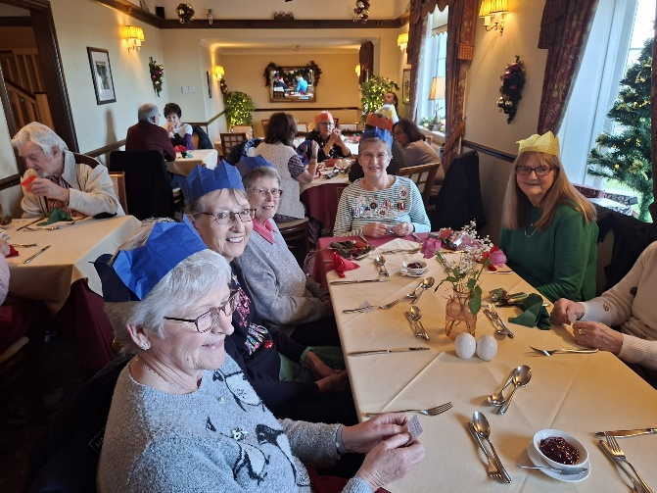
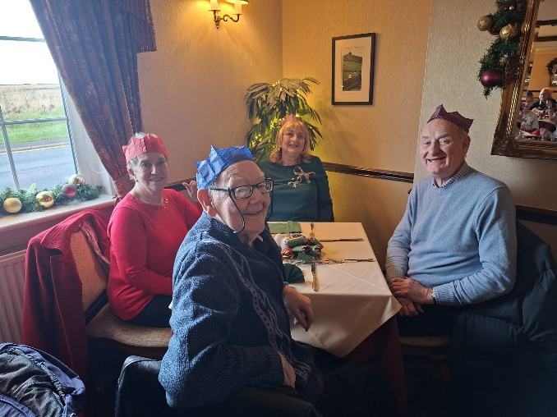
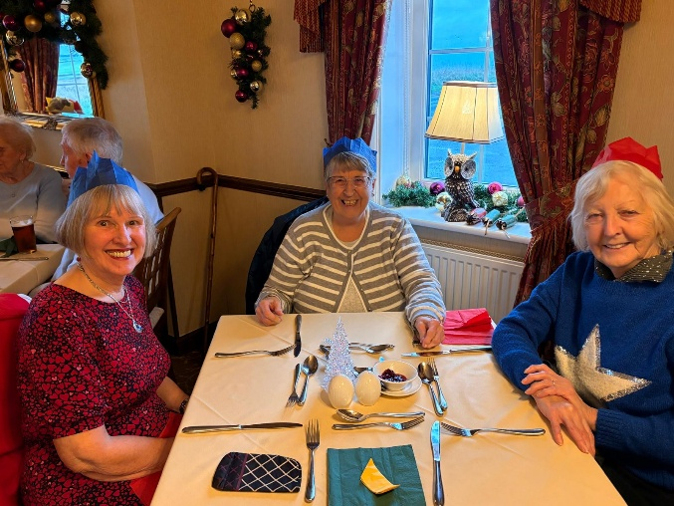
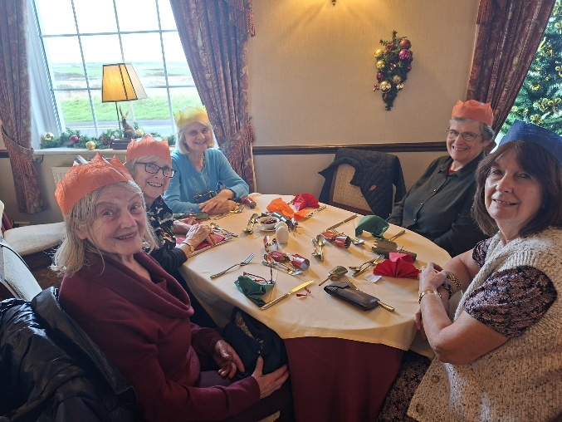

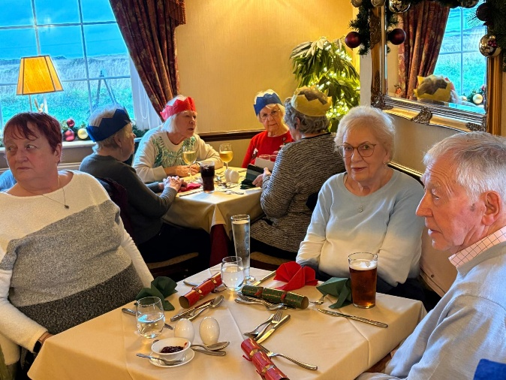
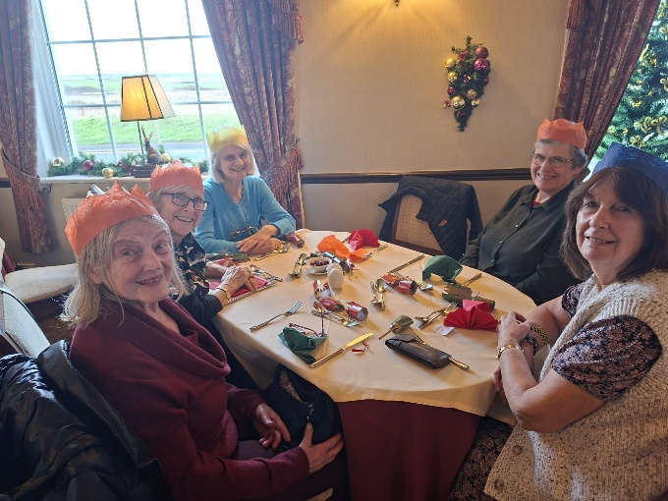

H&W u3a Christmas Social.

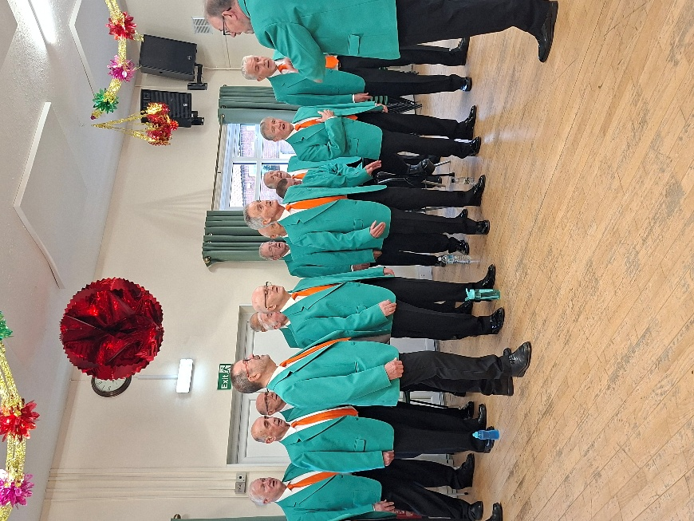
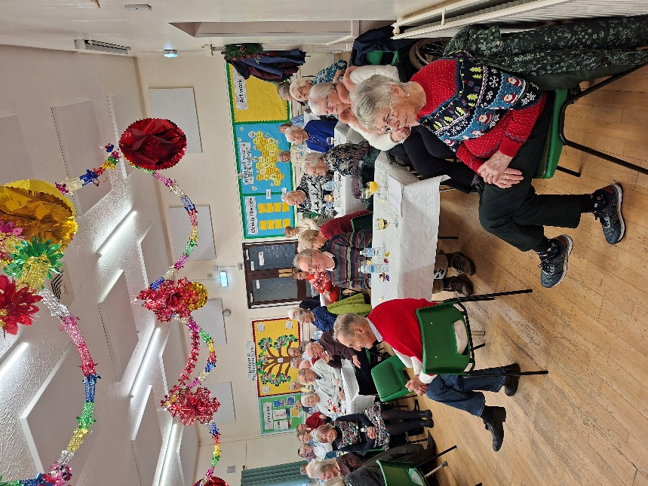

The Daytones performing at the Christmas Social

